Disabling Driver Signature Enforcement In Windows 8 Temporarily
NOTE: PLEASE PRINT THESE INSTRUCTIONS TO HELP DURING THE INSTALLATION PROCESS.
P
Step 1. Go to the right bottom corner of the desktop and wait for the side menu to appear. When it's there click on the gear icon with the title "Settings".
Step 2. Now click on the entry "More PC Settings", then click on the entry "General".
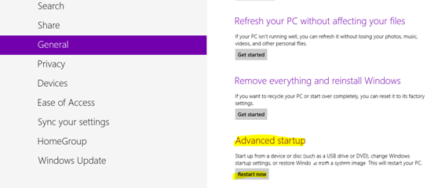
Step 3. Scroll down to "Restart now" (under "Advanced start up ") and click it.
Step 4. Wait a bit for a menu.
Step 5. Now click "Troubleshoot", then "Advanced Options" and after that click "Windows Start up Settings".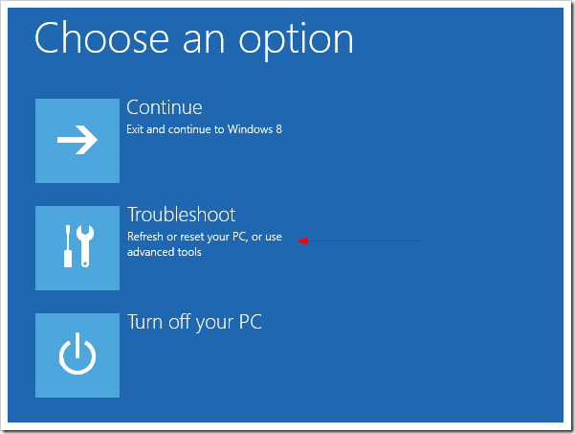
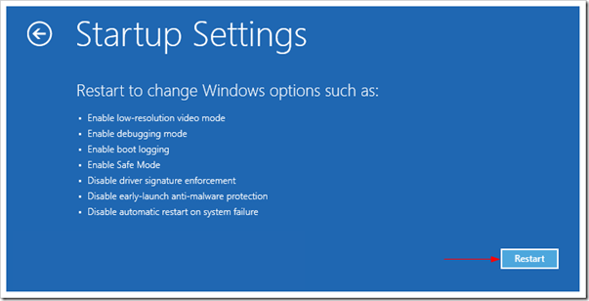

Step 6. Click on "Restart" and wait for the profit and select Disable Driver Signature Enforcement.
Once you did this you will be able to install unsigned drivers, just click "Install this driver" software anyway and this will install your driver.


